World Fudokan Federation WFF

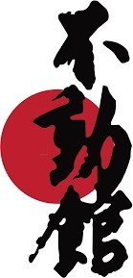

SPORTS KARATE

WELCOME

INVITATION LETTER

Dear Presidents of the National Federations,
dear Athletes, Coaches, Instructors, Officials, Judges and friends of Fudokan Karate,

WORLD FUDOKAN FEDERATION and FUDOKAN ASSOCIATION OF SERBIA have the greatest honor to invite all national federations to the 27th European Fudokan Karate Championship for cadets, juniors, youth, seniors and veterans, the 27th European Fudokan Cup for Children and the 3rd World Ikkaido Celebrations to be held on May 17th to 19th 2023 in Podcetrtek, Slovenia.

WELCOME to Slovenia!

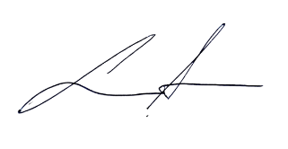

ALJOSA LIPAVC, 7. DAN
President of Fudokan association of Slovenia

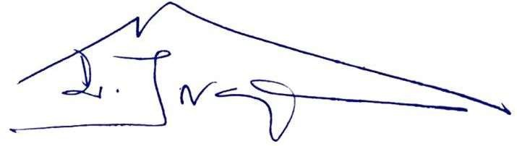

Univ. Prof. ILIJA JORGA, M.D., PhD, Soke 10. DAN
Founder of Fudokan and WFF

On behalf of WORLD FUDOKAN FEDERATION we have the greatest honor to invite all national federations to the 27th European Fudokan Karate Championship, for Children’s, Juvenil, Cadets, Juniors, under 21, Seniors, Masters and Veterans, to be held on May, 15th to 19th 2024 in the Sports Hall Terme – Olimia Podcetrtek – Slovenia
Official information regarding competition program, participation, protocols, accommodation etc. will be sent to you regularly and updated on our internet presentations: www.fudokansport.com and www.fudokaninfo.com
I am looking forward meeting you all of you there, dear friends, to become participants of this fantastic event in the most beautiful area!
With all our heart, we are inviting you to be a part of this very special event! We are counting on your presence, for a successful EUROPEAN Fudokan Karate Championship!

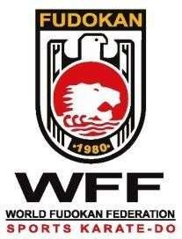27th European Fudokan Karate Championship 2024 27th European Fudokan Sport Karate CUP Podcetrtek – Slovenia
5
15th – 19th May 2024

FUDOKAN SPORT16KARATE CHAMPIONSHIP
Place: Sports Hall Terme – Olimia Podcetrtek – Slovenia

SPORTS KARATE PROGRAM:

“WFF for Children’s, Juvenil, Cadets, Juniors, Under 21, Seniors, Masters and Veterans”

16th May 2024 {Thursday}
10.00 – 18.00 Entry Registration
Place: congress hall –hotel SOTELIA- Office of the World Championship
- Credentiation to Coaches and Athletes
- 19.00h - Registration Deadline (In exceptional cases this deadline shall be extended, with prior notice, for delegations arriving late at the airport)
14.00 – 18.00 - Referees and Judges Course theory and practice (mandatory)
  - – 18.30 - Coaches Meeting (mandatory) sport and traditional together

FRIDAY - 17th May 2024
CHILDREN’S [1], JUVENIL [2], CADETS - Categories 1;2;3 and 4

08:30 – CHILDRENS [Categories A; B;] and JUVENIL Categories Start of competition individual Kata & Kumite
    - Elimination rounds, semi-final, and finals for Children Categories and Juvenil categories
    - Elimination rounds, semi-final, finals for JUVENIL TEAMS Categories

Medal Ceremony
13:00 – 14:00 Lunch break
14:30 – CADETS - Start of Individual Competition Kata & Kumite
    - Elimination rounds, semi-final, finals for Cadets Category

Medal Ceremony
    - Elimination rounds, semi-final, finals for CADETS TEAMS Categories
Medal Ceremony

SATURDAY - 18th May2024
JUNIORS, UNDER 21, SENIORS, MASTERS VETERANS, DISABILITY

Categories 5;6;7;8 and 9
08:30 – 22:00 Start and finished competition individual Kata & Kumite
    - Elimination rounds, semi-final, finals for Juniors
    - Elimination rounds, semi-final, finals for Under 21
    - Elimination rounds, semi-final, finals for Seniors
    - Elimination rounds, semi-final, finals for Veterans
    - Elimination rounds, semi-final, finals for Masters
    - Medal Ceremony

    - 17:00 Opening Ceremony {all participants}

  - End of competition
22:00 - E.F.C. Congress – Congress Hall

19th May 2024 – {Sunday} [All Teams] Categories 5;6;7;8 and 9 JUNIORS, UNDER 21, SENIORS, MASTERS, VETERANS
  - – 13.00 Start and finished individual Budo Sport and Teams Competition Kata & Kumite
    - Elimination rounds and Finals for all (Kata Team & Kumite Team)
    - Medal Ceremony

CATEGORIES and COMPETITIONS

"W.F.F. SPORTS”

Cat. | Kata / Kumite
1 | 1. CHILDREN A (until 7 years) | Ind. Competition - white to Orange / Green to Blue (All Styles)
2 | 2. CHILDREN B (8-10 years) | Ind. Competition - white to Orange / Green to Blue/ Brow to Black (All Styles)
3 | 3. JUVENIL (11-13 years) | Ind. Competition - white to Orange / Green to Blue/ Brow to Black - TEAMS (All Styles)
4 | 4. CADETS (14 to 15 years) | Individual weight Competition Categories all Belts - TEAMS (All Styles)
5 | 5. JUNIORS (16 to 17 years) | Individual weight Competition Categories all Belts - TEAMS (All Styles)
6 | 6. UNDER 21 (18 to 20 years) | Individual weight Competition Categories all Belts - TEAMS (All Styles)
7 | 7. SENIORS (21 to 35 years) | Individual Weight Competition Categories all Belts - TEAMS (All Styles)
8 | 8. MASTERS ( 36 to 50 years) | Individual Weight Competition Categories all Belts - TEAMS (All Styles)
9 | 9. VETERANS ( Up to 51 years) | Individual Competition all Belts / all weights - TEAMS (All Styles)

- CHILDREN A (until 7 years) Category 1
KATA – belt: white to orange/ Green to Blue (All Styles)

- CHILDREN B (8-10 years) Category 2

KATA – belt: white to orange/ Green to Blue / Brown to Black (All Styles)
KUMITE SHOBU NIHON all belts: weight categories (All Styles)
  - Weight for Male until 35 Kg. + Up 35 Kg.
  - Weight for Female: until 35 Kg. + Up 35 Kg.

- JUVENIL (11-13 years) Category 3

KATA – belt: white to orange/ Green to Blue / Brown to Black (All Styles) KUMITE SHOBU NIHON all belts: weight individual categories (All Styles) - TEAMS
  - Weight for Male: until 45 Kg. + Up 45 Kg.
  - Weight for Female: until 40 kg. + Up 40 Kg.

- CADETS (14 to 15 years) Category 4

KATA individual and TEAM Inter-style All Belts KUMITE SHOBU all belts: weight individual categories (All Styles) - TEAMS
  - Weight for Male: until 60 Kg. -65 Kg. +65 Kg.
  - Weight for Female: until 50 Kg. - 60 Kg. + 60 Kg.
  - KUMITE INDIV. AND KATA TEAM (All Styles, All Belts)

For all categories in "W.FF. General Karate- Sports federations can register unlimited number of competitors per category for Kata and for Individual Kumite
- Kata competitors can register inter-style only.
- - Its allowed to present all Katas and FUDOKAN Katas at the competition.

  - -All athletes must have their own regulation safeties (red / blue).
  - -It should be noted that the mask and bodice, are mandatory for all classes children.

-It is pointed out that for all classes, from kids to Master, the bodice is mandatory

- JUNIORS (16 to 17 years) Category 5
KATA individual and TEAM Inter-style All Belts KUMITE SHOBU all belts: weight individual categories (All Styles) - TEAMS
Weight for Male: until 65 Kg. - 75 Kg. + 75 Kg.
Weight for Female: until 55 Kg. - 65 Kg. + 65 Kg. KUMITE INDIV. AND KATA TEAM (All Styles, All Belts)

- UNDER 21 (18 to 20 years) Category 6
KATA individual and TEAM Inter-style All Belts KUMITE SHOBU all belts: weight individual categories (All Styles) - TEAMS
Weight for Male: until 65 Kg. - 75 Kg. + 80 Kg.
Weight for Female: until 60 Kg. - 65 Kg. + 65 Kg. KUMITE INDIV. AND KATA TEAM (All Styles, All Belts)

- SENIORS (21 to 35 years) Category 7
KATA individual and TEAM Inter-style All Belts KUMITE SHOBU all belts: weight individual categories (All Styles) - TEAMS
Weight for Male: until 70 Kg. - 80 Kg. + 80 Kg.
Weight for Female: until 60 Kg. - 65 Kg. + 65 Kg. KUMITE INDIV. AND KATA TEAM (All Styles, All Belts)

- MASTERS (36 to 50 years) Category 8
KATA individual and TEAM Inter-style All Belts KUMITE SHOBU all belts: weight individual categories (All Styles) - TEAMS
Weight for Male: until 75 Kg. + 75 Kg.
Weight for Female: until 65 Kg. + 65 Kg.
KUMITE INDIV. AND KATA TEAM (All Styles, All Belts)

- VETERANS (Up to 51 years) Category 9
KATA individual and TEAM Inter-style All Belts KUMITE SHOBU all belts all weights (All Styles) - TEAMS

KUMITE INDIV. AND KATA TEAM (All Styles, All Belts)

27th European Fudokan Karate Championship 2024 27th European Fudokan Sport Karate CUP Podcetrtek – Slovenia
9
15th – 19th May 2024

  - For all categories Federations can register unlimited number of competitors per category for Kata and for
Individual Kumite.
  - For Team Competition Federations can register 1 (one) team per category.
  - In the classification of the athletes it is taken into account from day / month / year of birth. Both in kata and Kumite.
For any questions see the “Rules Sport karate” in the website: www.fudokansport.com

REFEREES SEMINAR

16th May Thursday
14.00 – 18.00 Referees, Judges and Table Officers Course theory and practice (mandatory) for participate. Place:
- Each federation needs to bring at least one Referee or Judge, (Mandatory), who doesn’t fulfill the required obligation must pay 150 € in order to help support the competition. Referee´s will participate in the seminar and work during the competition. At the end of the competition all referees and judges will receive a Certificate of participation and a Certificate with the qualification achieved.
- Referees and Judges who possess a qualification from other international federations, W.F.F. Sport will recognize their qualification with a corresponding W.F.F. Sport qualification.
- It is necessary to make proof of qualifications.
COACHES MEETING

16th May Thursday

18.00 – 18.30 Coaches Meeting (Mandatory)
All coaches must attend the Meeting. Coaches who do not take part in the seminar will not be able to enter into the competition areas.
INSCRIPTIONS
If your Country (federations) has intention of participating in this 27th European Championship, contact with us. general.secretary@fudokansport.com

Only Federation/ Organization accepted by Fudokan Sports Karate, can participate in this 27th European Fudokan Karate Championship. All inscriptions is made by this karate platform. Because this is a World Platform our organization can be accept inscriptions or not:

Entries to the competition: OPEN-1st APRIL 2024 CLOSE 10th MAY 2024.

- Federations can edit their entries before the championship, in the hall for registration and weighing checks.
- It is mandatory that the legally responsible person for each federation shall bring the competitors passports to the Registration Room for the official check of the competitors ages.
- All competitors must come for weigh-in check in the Registration Room, together with their legally responsible person and their passports.

FEES
- Individual Participation (Kata or Kumite) Euro 40

TEAM PARTICIPATION Euro 60
- Referees Seminar: free
- Coach Seminar: free

PAYMENT

Entry fees are payable on account of WFF or cash at the Championship office in EURO or by account on request Entry fees are payable at the Championship Office in EURO by cash

-For further information please contact:
W.F.F. T.O.C. President: Aleksandar Simic e-mail: worldfudokan@gmail.com Phone +381 60 33 74 066 Chief coordinator: Marija Srejic e-mail: worldfudokan@gmail.com Phone +381 62 314 91

PARTICIPANTS:

    - Athletes officially selected by the WFF - National Federation Members of each country according to the following requirements:
    - Each country shall be represented by one official team.
    - Each athlete must be a citizen of the represented country.
    - Each athlete must know, thoroughly understand and be able to compete under the WFF Competition Rules.
    - Every participant must be free of any physical or mental handicap - therefore cannot cause any kind of difficulties during competition, under the WFF Rules.
    - All competitors must have Medical Release signed by official national doctor.

All athletes, participants must be in compliance with the medical certification of fitness work laws (with the inscription to the race the sports association President of the athletes belonging accepts responsibility for the compliance with this requirement stating implicitly that certified doctors are deposited in its registered office).All athletes who want to enter the 27th EUROPEAN FUDOKAN CHAMPIONSHIPS in Sports Karate Competition MUST have a Fudokan BUDOPASS with the Annual Visa – 2024

After drawing there will be NO possibility to make any changes.
      - Each National Federation must grant each register participant or visitor as for their own insurance (minimum 10.000 EUR).
      - The local organizer and the World Fudokan Federation – Sports Karate are not responsible for participant risk if participants are not insured. Personal belongings are always under responsibility of the owner.

Each participating Nation is required to bring its national flags 1,5 m x 2m.

If you need any more information’s, please contact:

    - General Secretary executive: Mr. Aleksandar Simic

EUROPEAN FUDOKAN CONFEDERATION- Phone +381 60 33 74 066 e-mail: worldfudokan@gmail.com

06st february 2024

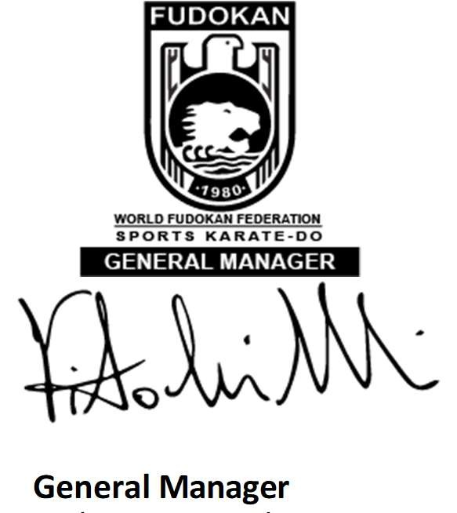
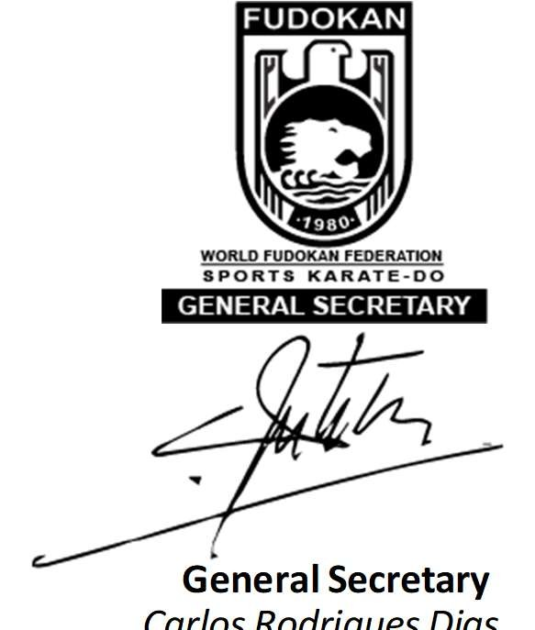
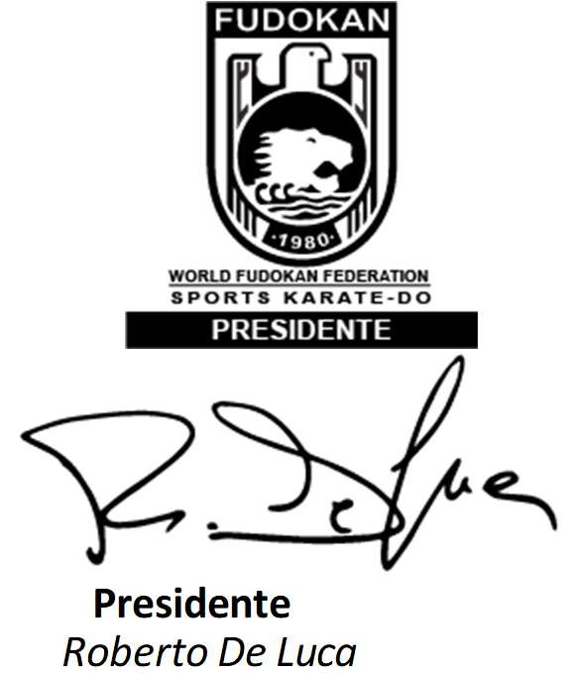
Vitaliano Morandi

General Manager

Presidente
Roberto De Luca

General Secretary
Carlos Rodrigues Dias

